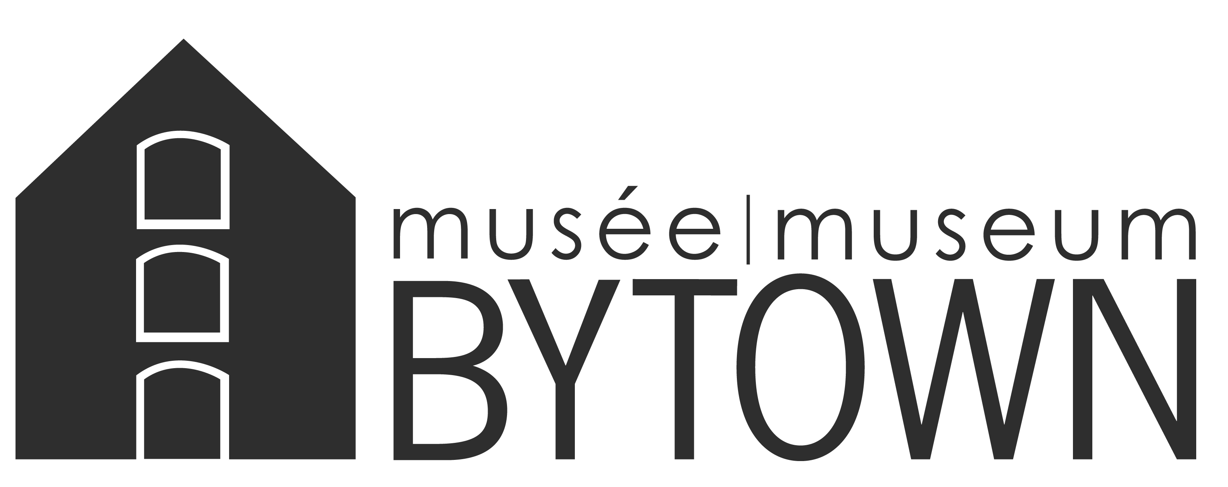
Located in the heart of downtown Ottawa, the MUSÉE BYTOWN MUSEUM explores the stories of an evolving city and its residents from its early days as Bytown to present day Ottawa.

Yes! I want to help the MUSÉE BYTOWN MUSEUM continue to preserve Ottawa heritage!

I am a returning volunteer I am a new volunteer Date:___/___/_____ dd/mm/yyyy

I am a member of the MUSÉE BYTOWN MUSEUM I am interested in becoming a member

Personal Information*: PLEASE PRINT CLEARLY

First Name:________________________ Last Name:________________________

Address:________________________________________________________________

City:____________________ Province:__________ Postal Code:____ ____

Telephone: (_____) _____-__________ Email:__________________________________

Areas of Interest:
Programming Special Events Collections Administrative

Other (please specify)_____________________________________

Do you have a special skill set you would like to exercise? Please specify:

Availability:

Monday | Tuesday | Wednesday | Thursday | Friday | Saturday | Sunday
AM | AM | AM | AM | AM | AM | AM
PM | PM | PM | PM | PM | PM | PM
Evening | Evening | Evening | Evening | Evening | Evening | Evening

Please return your completed form in confidence to the
BYTOWN MUSEUM PROGRAMMING MANAGER
MUSÉE BYTOWN MUSEUM, 1 Canal Lane, P.O. Box 523, Station B, Ottawa, ON K1P 5P6
(613) 234-4570 x226 visitorservices@bytownmuseum.ca www.bytownmuseum.com

* PRIVACY STATEMENT: We occasionally send our supporters information about our programs and activities at the MUSÉE BYTOWN MUSEUM. Your information will be protected and will not be shared with outside groups. For more information, please contact Robin Etherington, Executive Director at (613) 234-4570 x224.
Yes, I would like to be notified of events and activities at the MUSÉE BYTOWN MUSEUM.

