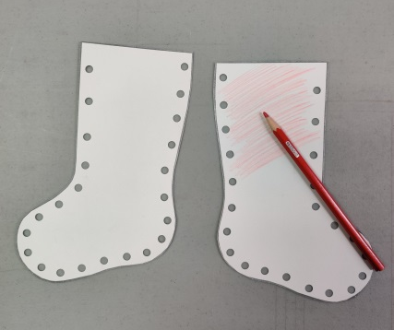
- Take two opposite facing stockings, decorate the outside of each stocking side
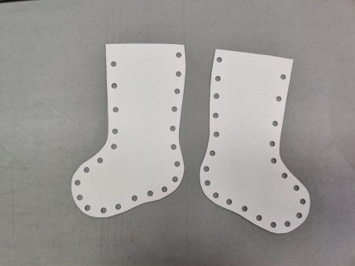

- Bring the two sides together and thread the yarn through the holes to “sew” the two sides together
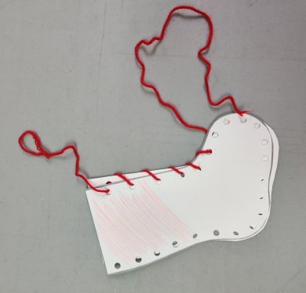

- Spread glue along the top of each side
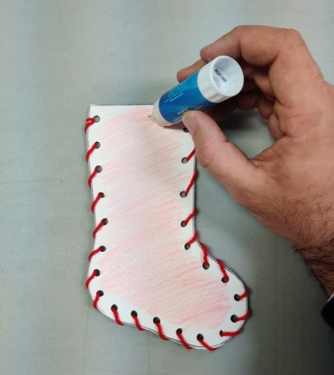

- Use the cotton to create the stocking’s white cuff
