**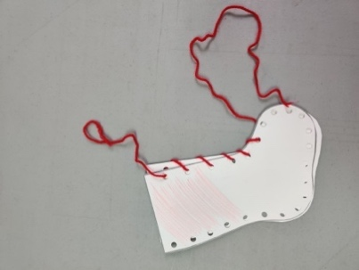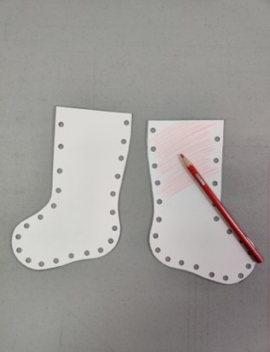****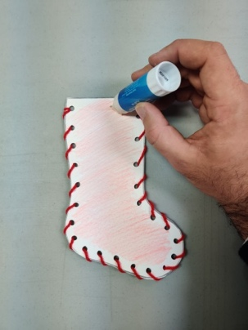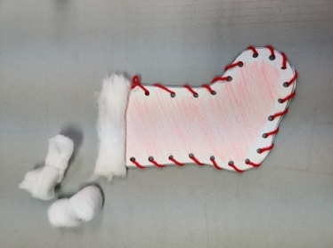**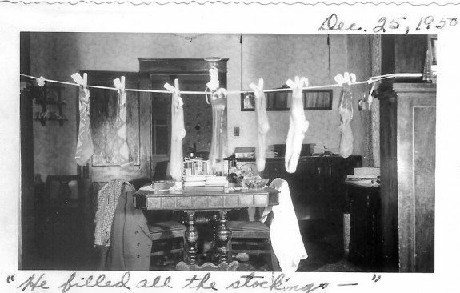

4) Spread glue across the top of the stocking on both sides

5) Use the cotton to create the stocking’s white cuff

3) Bring the two sides together. Thread the yarn through the holes to “sew” the two sides together.

2) Take two opposite facing stockings and decorate the outside of each stocking

1) Cut out the stocking template and use a hole punch around the outline of the stockings

**Instructions :**

An early legend of Christmas stocking from the years 270-343, recounted the story of three daughters awoke after St. Nicholas filled their stockings with gold coins so they would be rich enough to marry. Families began hanging their stockings on the fireplace hoping to be just as lucky!

**Supplies:**

* Paper or cardstock
* Hole punch
* Red yarn
* Glue stick
* Cotton wool
* Red pencil crayons, markers or crayons

